**Practical 04 Digital Presentation**

**Representing colour in RGB**

1. 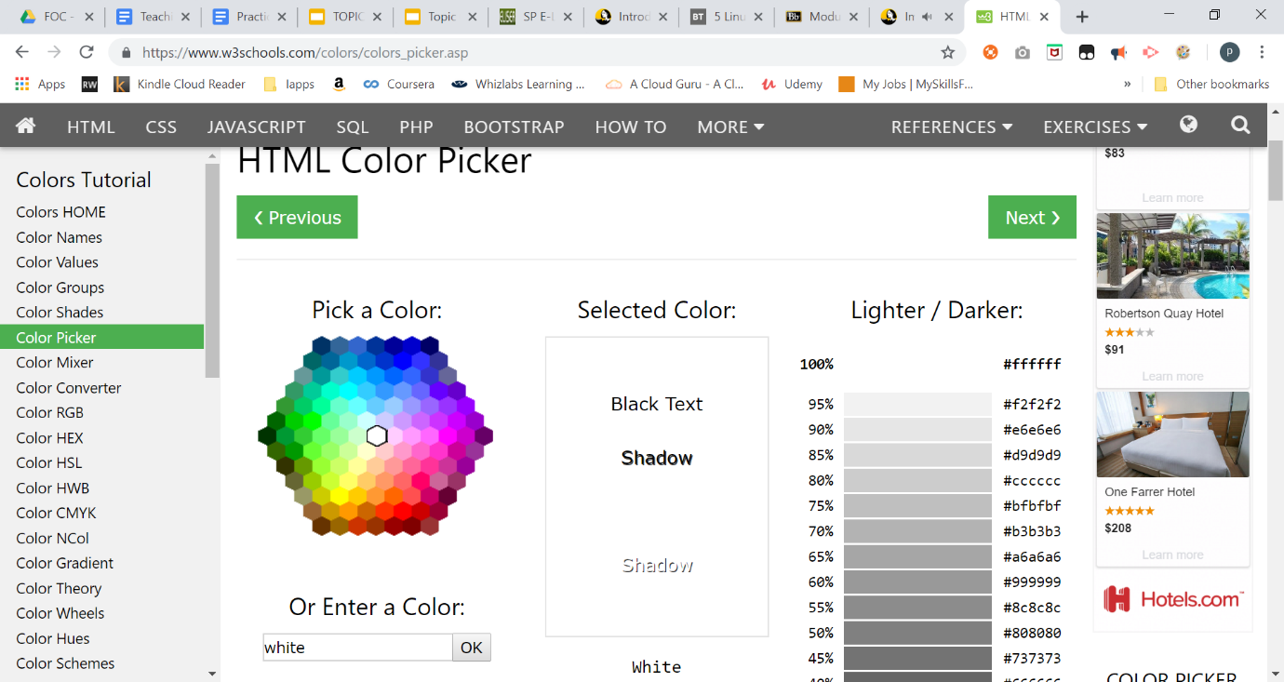Go to web site <https://www.w3schools.com/colors/colors_picker.asp>

|  |  |  |
| --- | --- | --- |
| **Colour** | **RGB in decimal** | **RGB In Hex** |
| Black | **RGB(0, 0, 0)** | **#000000** |
| White | **RGB(255, 255, 255)** | **#FFFFFF** |
| Navy blue | **RGB(0, 0, 128)** | **#000080** |

Access the File Header

1. Using notepad, create a text file named “file1.txt”

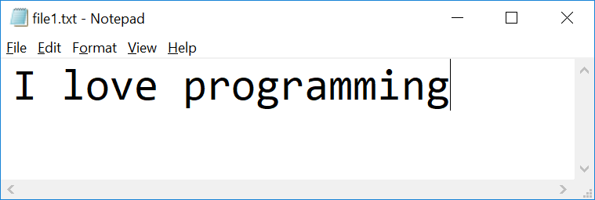

1. Check the file properties

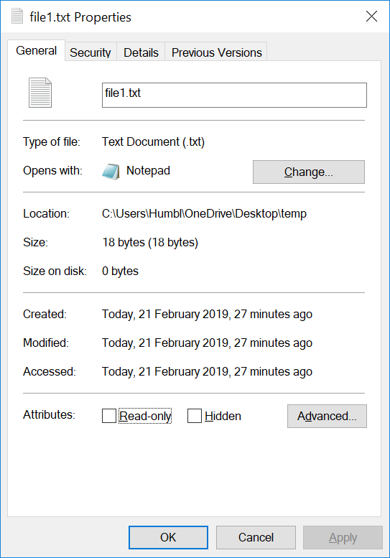

What is the size of the file in bytes?

|  |
| --- |
| 18 bytes |

1. Visit HexEd at <https://hexed.it/>

or download HxD Hex Editor

<https://download.cnet.com/HxD-Hex-Editor/3000-2352-10891068.html?part=dl-HxDHexEdi&subj=uo&tag=button>

1. Open file1.txt using HxD
2. Observe the Hex code  
   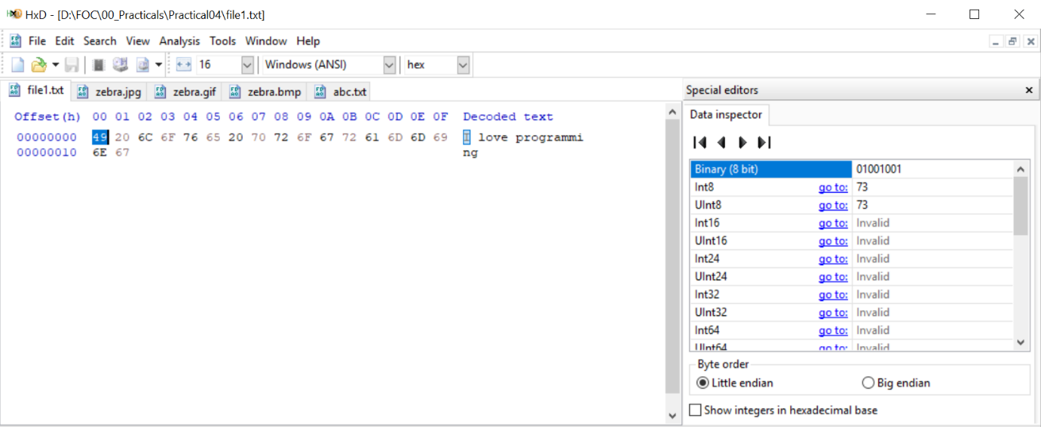

|  |  |  |
| --- | --- | --- |
| **Character** | **Hex** | **Binary(8 bit)** |
| I | 49 | 01001001 |

1. Using HxD to observe how character “o” and space character are represented

|  |  |  |
| --- | --- | --- |
| **Character** | **Hex** | **Binary(8 bit)** |
| o | 6F | 0110 1111 |
| space | 20 | 0010 0000 |

1. 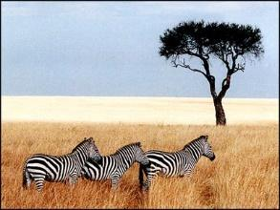Download the following image and save it as zebra.**jpg**, zebra.**gif** and zebra.**bmp**
2. Open **zebra.gif** in HxD

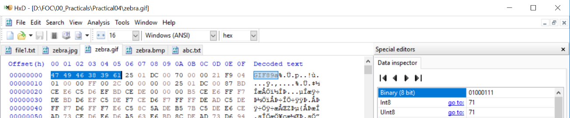Observe the Hex code

What are the **first 6 bytes** decoded?

|  |  |  |  |  |  |  |
| --- | --- | --- | --- | --- | --- | --- |
| **offset** | **00** | **01** | **02** | **03** | **04** | **05** |
| Byte | 47 | 49 | 46 | 38 | 39 | 61 |
| Character | G | I | F | 8 | 9 | a |

1. Visit web site <https://en.wikipedia.org/wiki/List_of_file_signatures> to find out the meaning of above hex code

|  |
| --- |
| GIF89a. The image, zebra.gif, is being encoded in the Graphics Interchange Format. |

1. Open **zebra.jpg** in HxD  
     
   Observe the Hex code

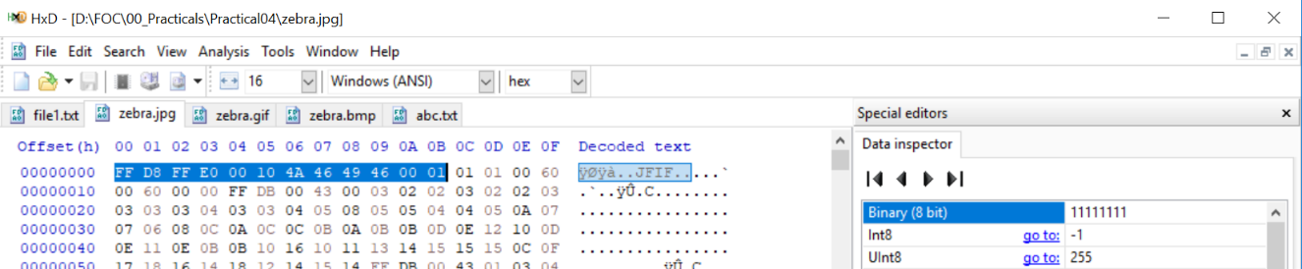

What are the **first 12 bytes**?

|  |  |  |  |  |  |  |  |  |  |  |  |  |
| --- | --- | --- | --- | --- | --- | --- | --- | --- | --- | --- | --- | --- |
| **offset** | **00** | **01** | **02** | **03** | **04** | **05** | **06** | **07** | **08** | **09** | **0A** | **0B** |
| Byte | FF | D8 | FF | E0 | 00 | 10 | 4A | 46 | 49 | 46 | 00 | 01 |
| Character | blank | ǂ | blank | α | . | . | J | F | I | F | . | . |

1. Visit web site <https://en.wikipedia.org/wiki/List_of_file_signatures> to find out the meaning of above hex code

|  |
| --- |
| The image, zebra.jpg, was encoded in the format of JPEG raw/JFIF/Exif. |

1. Open **zebra.bmp** in hex editor

Observe the Hex code   
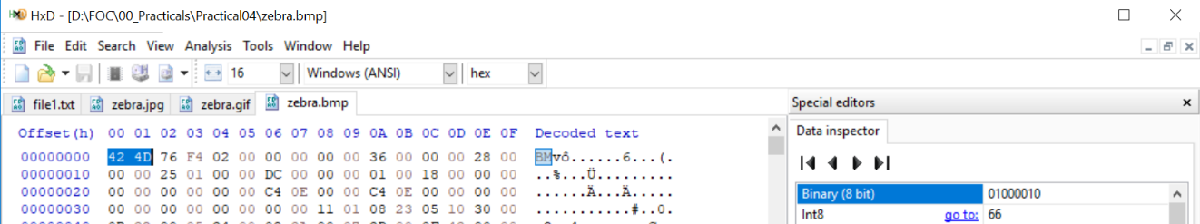

What are the **first 2 bytes**?

|  |  |  |
| --- | --- | --- |
| **offset** | **00** | **01** |
| Byte | 42 | 4D |
| Character | B | M |

1. Visit web site <https://en.wikipedia.org/wiki/List_of_file_signatures> to find out the meaning of above hex code

|  |
| --- |
| The image, zebra.bmp, was encoded in BMP format, which is a bitmap format that is mostly used in the Windows system. |

1. (optional)  
   Download the file at <https://drive.google.com/open?id=1vf0SBkI1LdWQvYmK9yM5AyJ0fHKE6DHR>

How can you view it as an image?

|  |
| --- |
| I can view the file as an image by opening the file in the HxD. Then, check the first few decoded texts in HxD to the list of file signatures. After that, save the file as the file format found in the list of file signatures. The image could then be viewed. However, I could not view the file as an image. The picture below shows that the image cannot be opened. |

**Hint:**

* Open the file using HxD
* Visit web site <https://en.wikipedia.org/wiki/List_of_file_signatures> to find out the meaning of above hex code
* Rename the extension of the file

*End of Practical*